ME 7120 FEA

Project 3

Newmark Method

by

Admir Makas

Introduction

This report discusses the results obtained from the use of Newmark method in order to solve a L-beam problem that is loaded by an impulse with a magnitude of 100,000 N. Figure 1 shows the definition of the structure.

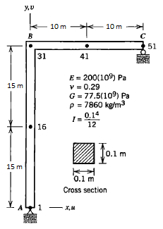

**Figure 1**: Structure and material properties.

The structure is comprised of 51 nodes and 50 2-D beam elements, each of length 1m. The structure is pinned at location A and simply supported at location C such that displacement in y-dir. is not allowed. The structure is loaded by an impulse load shown in Figure 2.

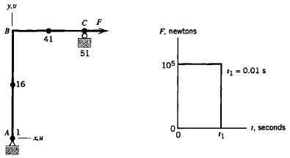

**Figure 2**: Loading profile for the structure.

Stiffness (**K**) and mass (**M**) matrices are generated using 2 nodded beam element from project #1. Since the problem defined in Figure 1 is in 2-D space the unnecessary degrees of freedom, which is in this case are displacement in y-dir and rotations about x and z, were removed. Therefore, the size of **K** and **M** matrices is reduced from 306X306 to 150X150. The degrees of freedom that were kept are displacements in x and z directions along with rotation about y-axis for each node of the system.

Model Validation

The reduced matrices were used to calculate the first 5 natural frequencies along with their respective mode shapes. This was done in order to compare the results found in the FEA book by Cook. Results from the book can be seen in Figure 3.

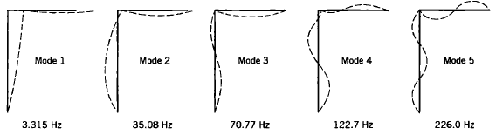

**Figure 3**: First 5 modes from the L-bracket (Book Results)

Results from the reduced matrices can be seen in Figure 4. It can be seen that the results obtained from the reduced **M** and **K** closely match the book results. Based on this evaluation it was deemed sufficient to use the derived model for the dynamic loading analysis based on the loading profile seen in Figure 2.

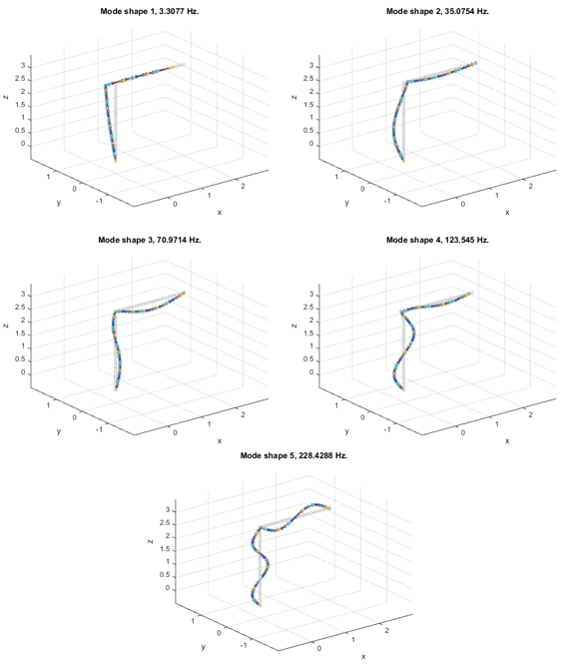

**Figure 4**: First 5 modes for the L-bracket (reduced **M** and **K**)

Dynamic Loading Analysis

For the dynamic analysis Newmark method was used. Table 1 shows the 5 different combinations of β and γ that yield different methods.

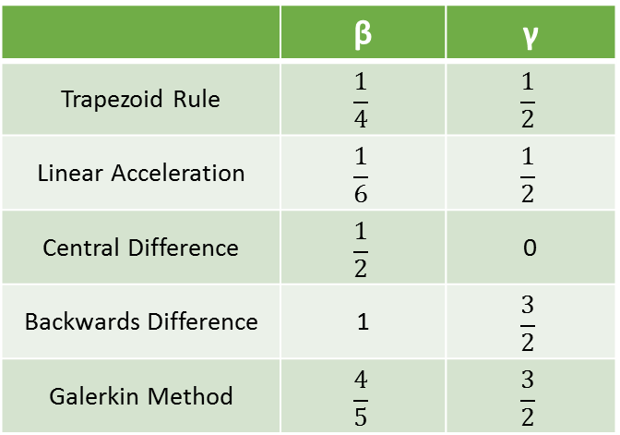

**Table 1**: List of methods used to calculate structure response.

This combination of β and γ was implemented in the Newmark method that is outlines in the diagram below. The implementation did not use any damping.

